EXPERIMENT 10

Performance Optimization in Zoho Creator
SAHANA R
241401086

Aim
To demonstrate performance optimization techniques in a Zoho Creator application, particularly efficient record retrieval and workflow processing.

Introduction
Performance optimization in low-code applications means designing forms, workflows and scripts so that they use data and processing only as far as needed. Although a low-code platform handles much of the underlying work, the way in which a workflow is written still influences how efficiently it runs.
Retrieving more records than required, or repeatedly processing records that are not relevant to the task, causes unnecessary data retrieval and processing. In a small application this may not be noticeable, but as the number of records and users grows it can reduce application efficiency. Efficient workflows in Zoho Creator therefore retrieve only the data they need and avoid unnecessary processing, which supports scalable and maintainable applications.

Application Used
The practical was performed in Zoho Creator 6 using the Student Admission Enquiry Form application. Deluge scripting was used to write the logic of a form workflow, “Notify the student”, that sends an email notification when an admission enquiry is submitted. The Zoho Creator account was on a trial plan, so some advanced features required an upgrade; no upgrade-only feature is claimed as enabled or configured in this record.
241401086

Performance Optimization Concept
The key optimization demonstrated is criteria-based record fetching. Instead of retrieving every record of a form, a criteria is given so that only the required record is returned. In the Student Admission workflow, this is written as:

studentRecord = Student_Admission[ID == input.ID];
- The workflow identifies the current record using input.ID, which holds the ID of the record being processed.
- Only the relevant Student Admission record, the one whose ID matches input.ID, is retrieved.
- This avoids unnecessarily fetching and processing unrelated records.
- This improves workflow efficiency and reduces unnecessary data processing.

Procedure
- Open the Student Admission Enquiry Form application in Zoho Creator in Edit mode.
- Navigate to the Workflow section and open Form workflows. The form Student Admission is listed under Forms with workflows.
- Observe the form workflow “Notify the student”. It is triggered on Created → Successful form submission, has 3 actions and has the status Enabled (Figure 1).

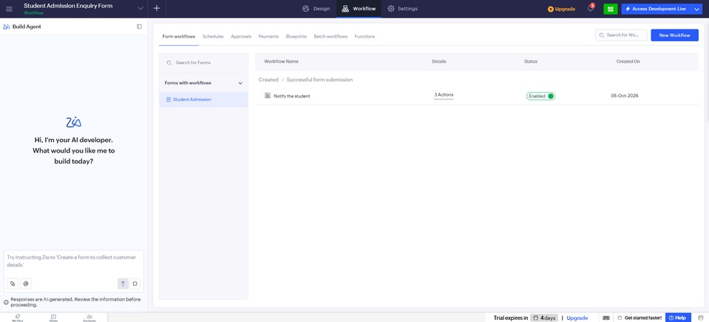
Figure 1: Form Workflow of the Student Admission Enquiry Form Application (Actual Screenshot)
- When a Student Admission form is submitted, the workflow identifies the current record using input.ID.
- The required record is fetched using the criteria ID == input.ID, so that only this record is retrieved.
- The workflow checks whether the email field of the record is blank.
- If the email is available, the notification email is sent to the student. If the email is missing, an informational message is displayed.
The Deluge script used in the workflow is given in the next section.

Deluge Code
241401086
The Deluge code of the workflow is as follows:

studentRecord = Student_Admission[ID == input.ID]; if(studentRecord.email.isBlank())
{
info "Email address is missing for this enquiry";
}
else
{
sendmail [
from :zoho.adminuserid to :studentRecord.email
subject :"Your Admission Enquiry has been Received"
message :"<p>Dear Student,</p><p>Your admission enquiry has been received.
We will contact you shortly with further details.</p><p>Thank you for your interest in our institution.</p>"
]
}
The first statement fetches the record by its ID. If the email field of that record is blank, an informational message is displayed. Otherwise, an email with the subject “Your Admission Enquiry has been Received” is sent to the student’s email address.

Performance Analysis
The optimized approach is compared with a general inefficient approach below.

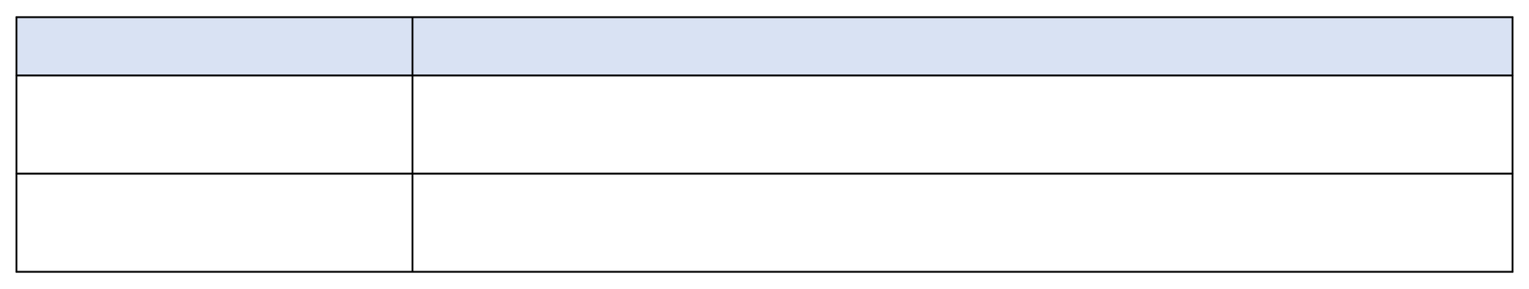
Approach
Before (inefficient approach)
Optimized (used in the workflow)
Steps
Fetch all records → iterate through records → find the required record → process Fetch the required record using ID → process directly

The inefficient approach retrieves and processes records that are not needed, whereas the optimized approach reduces unnecessary record retrieval and processing. Figure 2 is a conceptual diagram that illustrates this comparison. The “before” code in it is an illustrative example only; it was not used in the application.

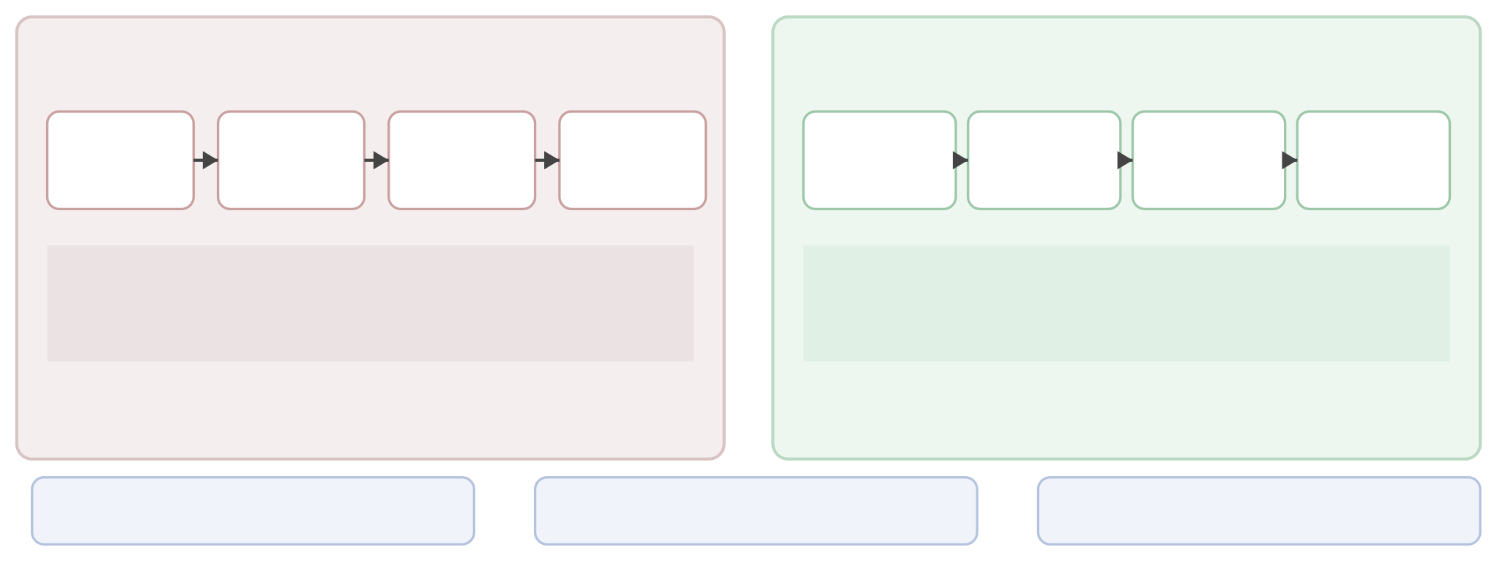
Performance Optimization in Zoho Creator
Inefficient Approach
Optimized Approach
Fetch All Records
Loop Through Records
Find Required Record
Process
Criteria-Based Fetch
Validate Required Data
Process
Send Notification
stdRequests = Student_Admission[];
for each rec in stdRequests { if(rec.ID == input.ID) {...} }
studentRecord = Student_Admission[ID == input.ID];
Retrieves and processes unneeded records.
Fetches only the required record.
Reduced Data Retrieval
Faster Processing
Better Workflow Efficiency

Figure 2: Inefficient and Optimized Approaches (Conceptual Diagram)
241401086

Illustrative comparison only (not used in the application):

serviceRequests = Student_Admission[]; for each rec in serviceRequests
{
if(rec.ID == input.ID)
{
// ...
}
}
No benchmark was performed in this practical, so no measured improvement in execution time is claimed. The comparison is based on the amount of data retrieved and processed.

Optimization Techniques

General practices that contribute to performance in Zoho Creator applications are given below and shown in Figure 3, a conceptual diagram.

Performance Optimization Techniques

Criteria-Based Fetching Retrieve only the required records.
Avoid Unnecessary Loops
Do not fetch all and
iterate when a criterion can be used.
Efficient Built-in Operations Use built-in and
aggregate operations.
Indexed Fields

May improve retrieval; backend/platform configuration.
Optimized Workflow Processing
Keep workflows simple;
avoid nested/repeated operations.
Less Data Retrieval
Less Processing
Better Performance
Efficient Resource Usage

Technique
Figure 3: Performance Optimization Techniques (Conceptual Diagram)
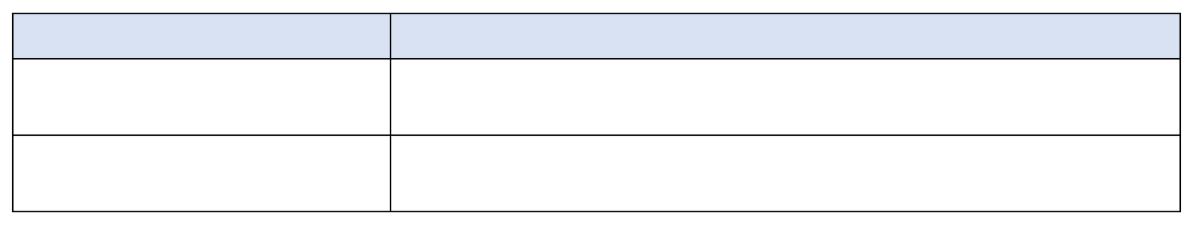
Explanation

Criteria-based record fetching

Avoiding unnecessary record iteration
Retrieve only the records required for the current operation. This technique is used in the practical.
Do not fetch all records and loop through them when a specific criterion can be used.

Efficient built-in functions and  aggregate operations | Use built-in functions and aggregate operations instead of unnecessary repeated processing.
Indexed fields | Indexed fields can improve retrieval performance for frequently queried data. Indexing may require backend / platform configuration, and it was not enabled or configured in this application.
Efficient workflows | Keep workflows simple and avoid unnecessary nested or repeated operations.

Optimized Workflow
241401086
Figure 4 is a conceptual diagram of the optimized Student Admission workflow:
Student Admission Submitted → Identify Current Record → Criteria-Based Record Fetch → Validate Email → Prepare Notification → Send Email

Optimized Student Admission Workflow

input.ID Student_Admission [ID == input.ID]
Student Admission Submitted
Identify Current Record
Criteria-Based Record Fetch
Validate Email Field
Prepare N n
otificatio
email.isBlank()

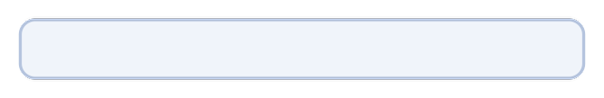
Targeted Record Retrieval
Minimal Processing
Efficient Workflow Execution

Figure 4: Optimized Student Admission Workflow (Conceptual Diagram)
- Identify current record: input.ID gives the ID of the submitted record.
- Criteria-based record fetch: Student_Admission[ID == input.ID] retrieves only the relevant record.
- Validate email: email.isBlank() checks whether the email field is empty.
- Prepare notification and send email: if the email is available, the notification message is prepared and sent using sendmail; otherwise an informational message is displayed.

Conclusion
Performance optimization is important in low-code applications because efficiency depends not only on the platform but also on how workflows and scripts are written. In this practical, the Student Admission workflow used criteria-based record retrieval with the expression Student_Admission[ID == input.ID], so that only the required record was retrieved and processed.
Targeted record retrieval improves efficiency by avoiding the retrieval of unrelated records and the iteration through them, and efficient workflow design reduces unnecessary processing. Practices such as criteria-based fetching, avoiding unnecessary loops, using built-in operations and keeping workflows simple help applications to handle growing amounts of data. These practices contribute to scalaSbelned and maintainable Zoho Creator applications. No benchmark was performed, so the benefits are descErimbaeil d in terms of reduced data retrieval and processing and not as measured execution times.
241401086

